Wiking Kujon
First Robotics Team 6077

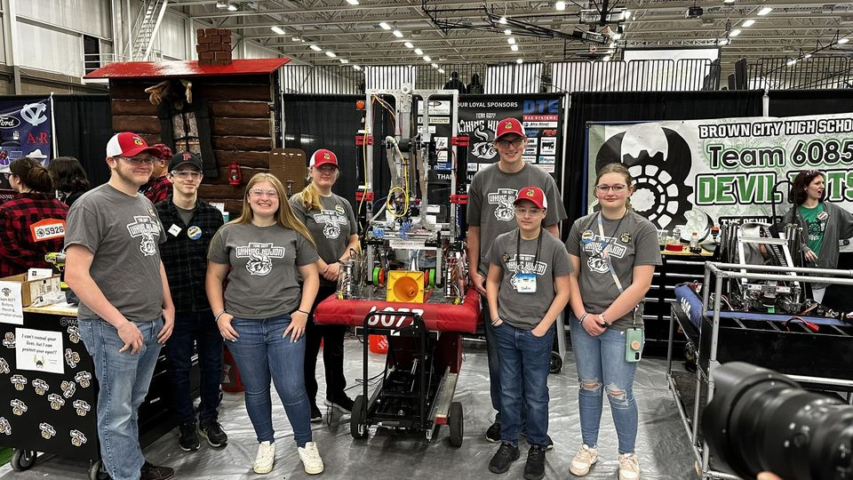

Team Info:
Posen Wiking Kujon 6077 Robotics Team
FRC6077@gmail.com
Wiking Kujon: Nerdy Vikings in Polish!

Mentors:
Brian Konieczny
Nick Kowalski

Team Pages and Social Media:

FRC Team Page:
https://frc-events.firstinspires.org/2024/team/6077

Blue Alliance Team Page:
https://www.thebluealliance.com/team/6077/2024

Facebook Page:
https://www.facebook.com/Team6077/?hc_ref=NEWSFEED&fref=nf

X (Formally known as Twitter):
https://twitter.com/Team6077_

Competition Information:

Download the "Blue Alliance" and the “FRC Spyder” apps on Google Play or the Apple Store to follow the team during the competition!

1st District Competition:
Lake City School, 251 Russell Rd, Lake City, MI on March 8th – 10th

Event Information and Live Stream
https://frc-events.firstinspires.org/2024/MILAC

Event Statistics and Live Stream
https://www.thebluealliance.com/event/2024milac

```````````````````
2nd District Competition:
Lake Superior State University, Sault Sainte Marie, MI on March 14th – 16th

Event Information and Live Stream
https://frc-events.firstinspires.org/2024/MILSU

Event Statistics and Live Stream
https://www.thebluealliance.com/event/2024milsu

```````````````````
Michigan State Championship - (If we qualify for the event)
Saginaw Valley State University - Saginaw, MI on April 4th – 6th

Event Information and Live Stream
https://www.firstinspires.org/team-event-search/event?id=68474

Event Statistics and Live Stream
https://www.thebluealliance.com/event/2024micmp

Interesting Link:

Top 10 Differences Between Athletic Sports and Robotics
http://leadwithastory.com/top-10-differences-between-high-school-sports-and-robotics/

